#####################-------- LOAD BALANCERS--------###############

- Configure Classic Load balancer.
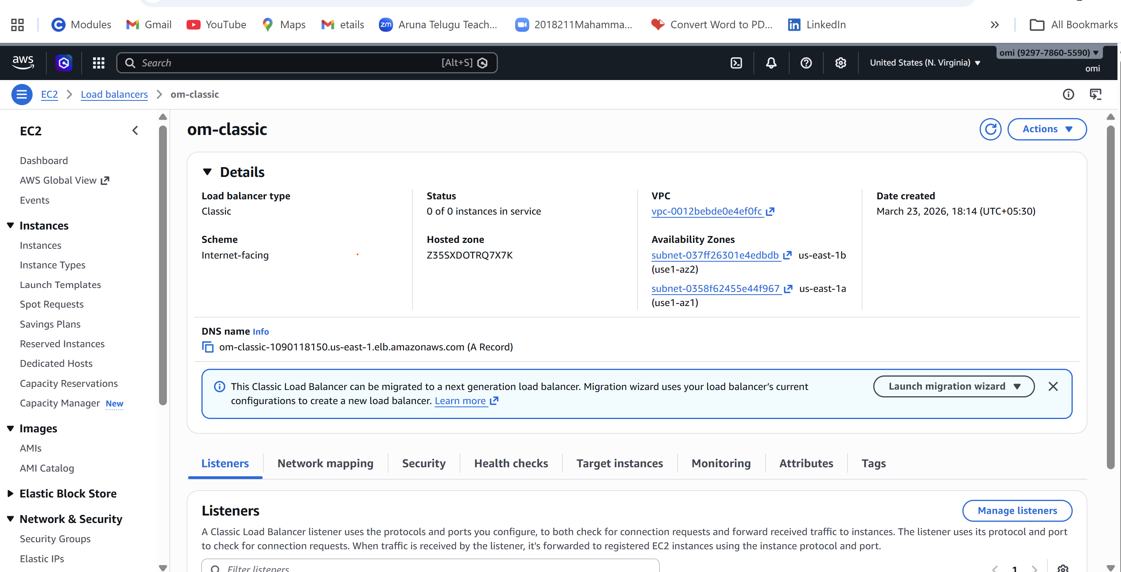

- Configure Application Load balancer.
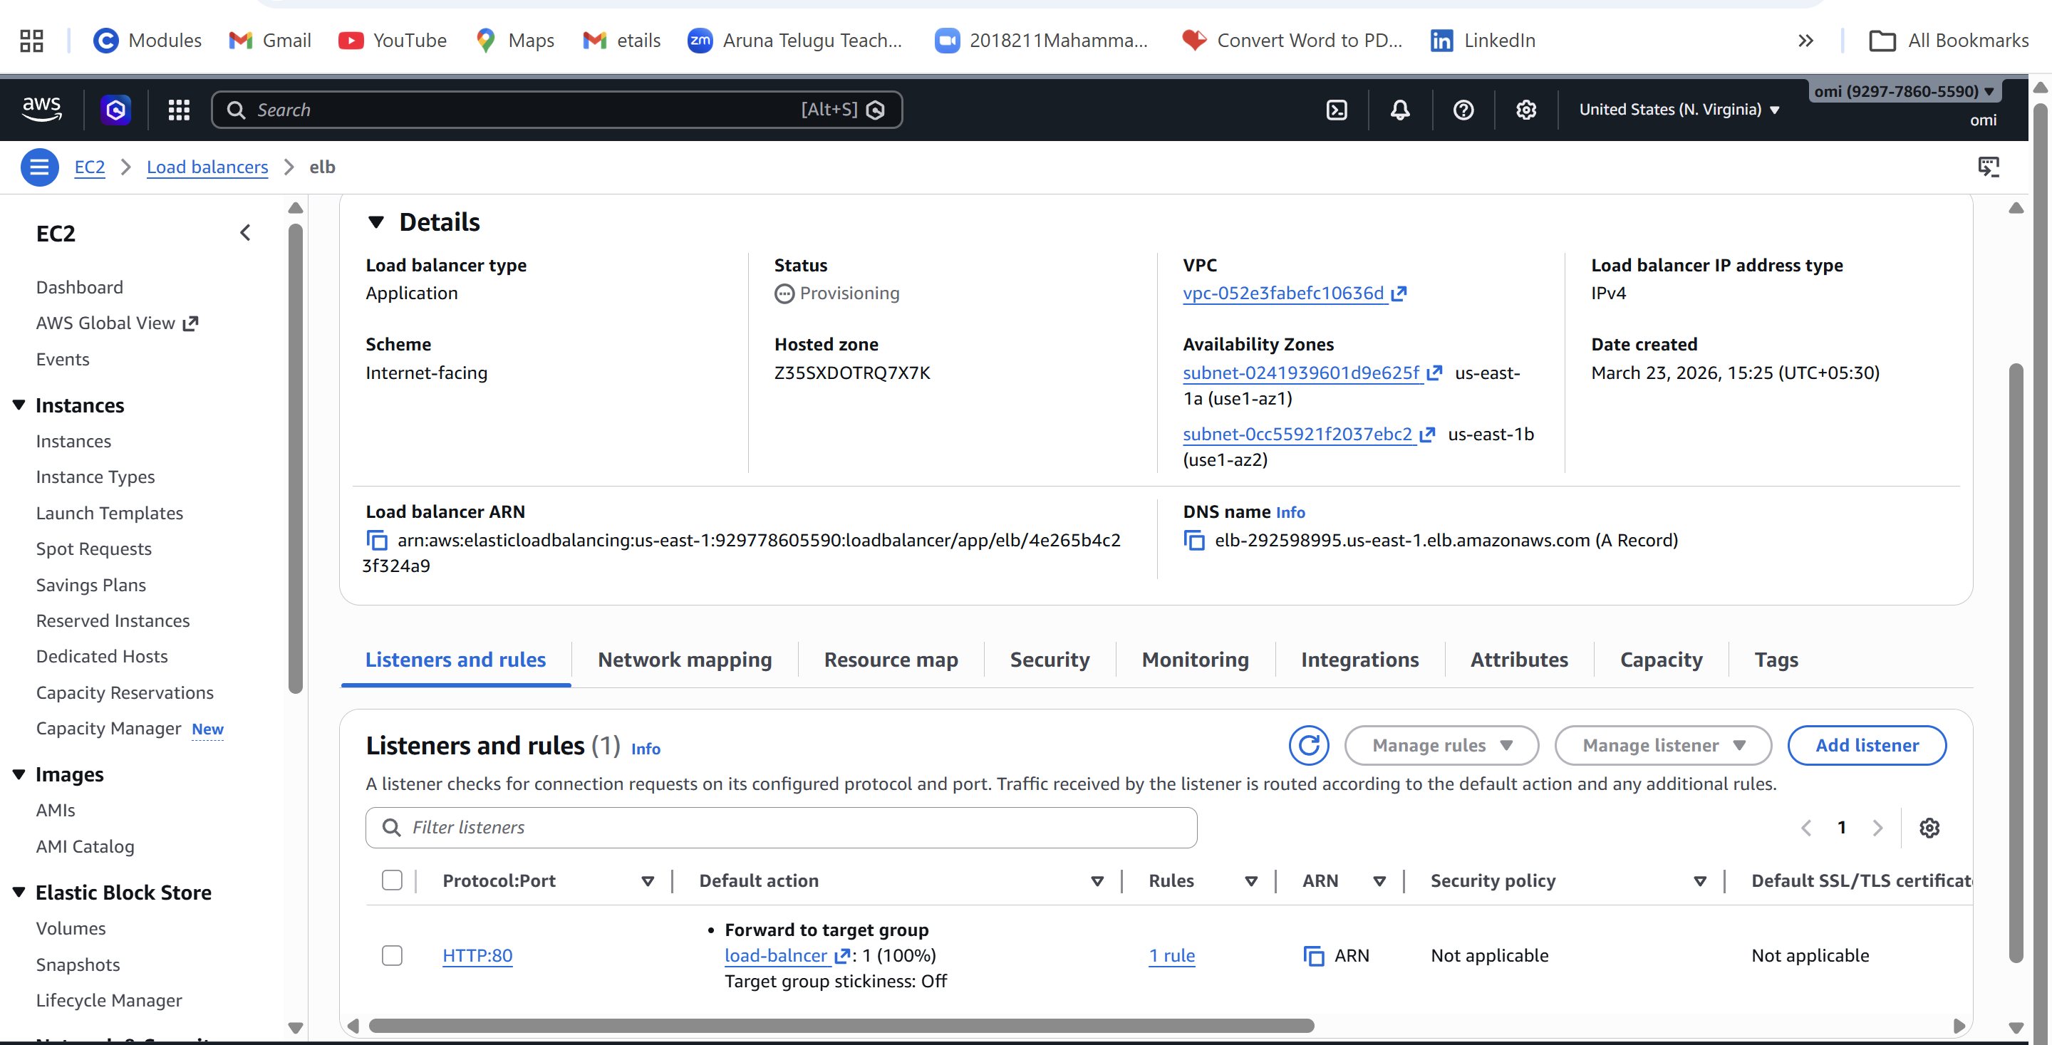
- Configure Network Load balancer.
- Attach SSL for application load balancer.
- Map Application load balancer to R53.
- Push the application load balancer logs to S3.

